**Plaza Premium Group announces new leadership appointments**

***Names Chief Commercial Officer and Chief Transformation Officer***

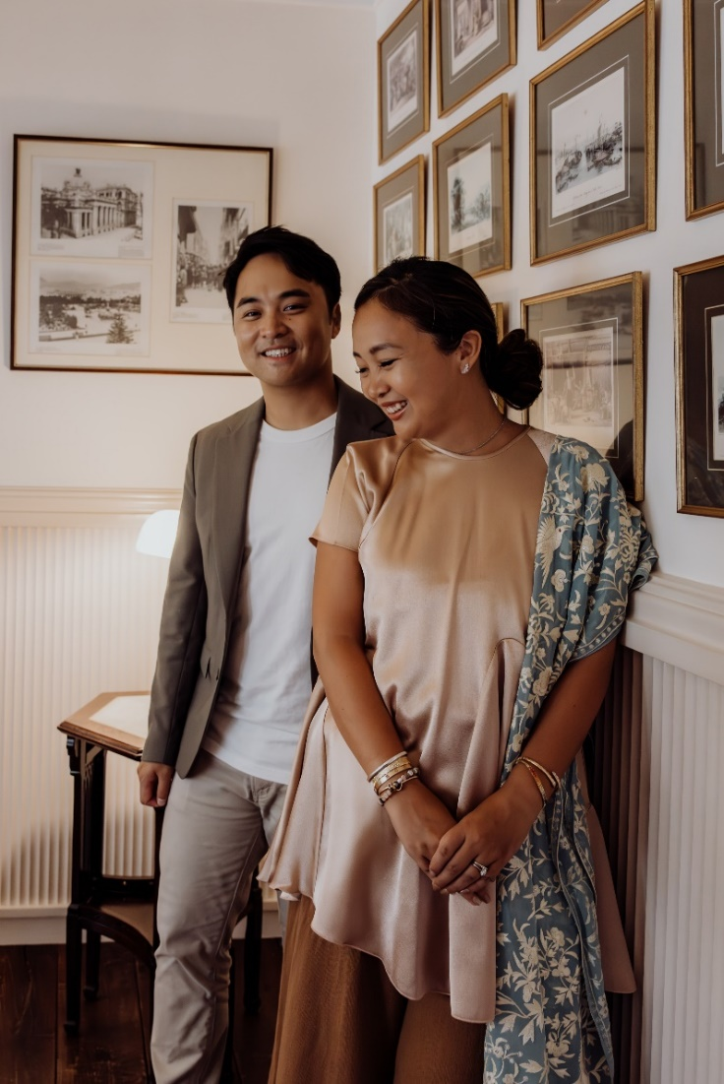

[HONG KONG, Aug 29, 2024] - Plaza Premium Group (PPG), the leading global airport hospitality services provider, announced that it is strengthening its leadership as it builds on 26 years of excellence, by appointing Jonathan Song and Mei Mei Song to new positions.

Jonathan, the global director of business development, has been named Chief Commercial Officer, while Mei Mei, the director of global brands and transformation, is assuming the position of Chief Transformation Officer. Both roles are effective immediately.

Founded in Hong Kong, PPG is the eight time winner of Skytrax’s World’s Best Independent Airport Lounge, and operates in 30 countries, 75 airports, and serves more than 20 million customers a year. PPG’s airport hospitality offerings also include dining outlets, airport terminal hotels, and the ALLWAYS concierge services.

“As the founder of a family-run global business, I’m immensely proud that both my children have been actively involved in growing PPG. Combined, they have spent more than two decades working with all of our dedicated teams and have experienced first-hand the many changes in the travel industry,” said Mr. Song Hoi-see, Founder and CEO of PPG. “As business continues to recover, we believe this is the right time to build up our leadership structure and to place more responsibility into the hands of the next generation.”

In his new capacity, Jonathan will spearhead the global development of new airport hospitality services and facilities in new airports. He will also lead key strategic partnerships, enhancing and growing sales channels, product development, and drive PPG's loyalty program - Smart Traveller. Mei Mei will oversee the brand’s evolution and implement transformation initiatives including enhancing customer experiences, diversifying PPG’s sales mix and anticipating future trends and opportunities. She is also leading PPG’s sustainability strategy.

"Watching my parents build the business from zero base was a formative experience that taught me invaluable lessons. Their tireless efforts established a rock-solid foundation for PPG, leading it to become a global leader in airport hospitality services. I am ready to bring in fresh perspectives and innovative ideas to PPG, elevating it to new heights and driving even greater impact within the industry." said Jonathan.

“Growing up in this family business, airports were my playground,” said Mei Mei. “Now, as I fly frequently for PPG, airports are my office, and I’ve witnessed the tremendous transformations in the travel industry, and seen PPG grow and evolve. I’m excited to turn my observations into innovative ways to help reshape the future of travel.”

|  |  |
| --- | --- |
|  |  |
| Mei Mei Song, Plaza Premium Group’s Chief Transformation Officer | Jonathan Song, Plaza Premium Group’s Chief Commercial Officer |

Download high-res photos here: <https://www.dropbox.com/scl/fo/9b4pcvtm64vekdch1j2nf/AIEmh0JIv1gy3cHi_NpdHWE?rlkey=ckq3vqsskn9pteq5d617e2fvh&st=ahx943jq&dl=0>

**About Plaza Premium Group**

Plaza Premium Group, headquartered in Hong Kong and established in 1998, is a pioneering global airport hospitality services provider. With a mission to Make Travel Better, the group introduced the world's first independent airport lounge concept.   
Today, PPG operates the largest network of international airport lounges worldwide and offers a 360-degree airport experience with 13 brands under its portfolio, spanning over 1600 touchpoints across more than 75 international airports and 30 countries & regions worldwide.

From airport lounge brands - Plaza Premium Lounge & Plaza Premium First, to terminal hotels - Aerotel & Refreshhh by Aerotel, to concierge services - ALLWAYS, a range of airport dining concepts, global reward and membership program - Smart Traveller, and travel experience ECOsystem - oneTECO, the group is at the forefront of transforming airport experience for the better through innovative and human-led solutions. PPG’s commitment extends beyond its own brands, as it also provides lounge management and hospitality solutions to leading airlines, alliances, and corporates worldwide. Partnerships include renowned names such as American Express, Capital One, Cathay Pacific Airways, SkyTeam, Star Alliance, Visa, and many more.

Plaza Premium Group has over 80 accolades demonstrating its exceptional achievements and commitment to service excellence. Notably, the group has received the prestigious "World's Best Independent Airport Lounge" award at the World Airline Awards by Skytrax for eight consecutive years from 2016 to 2024. TTG Asia also recognized the group as the "Best Airport Lounge Operator" in 2018, 2019 and 2023. In 2020, it achieved the "ISO 9001:2015" certification for its Hong Kong Headquarters. Furthermore, the group's Founder and CEO, Mr. Song Hoi-see, was awarded the “Ernst & Young Entrepreneur of the Year” and “Master Entrepreneur of the Year Malaysia” in 2018.

With a team of over 5,000 dedicated talents, PPG serves more than 20 million global passengers annually. Through a continuous pursuit of innovation and excellence, the group is experiencing exponential growth globally.

To learn more: [https://www.plazapremiumgroup.com/](https://apc01.safelinks.protection.outlook.com/?url=https%3A%2F%2Fwww.plazapremiumgroup.com%2F&data=05%7C02%7Cwhitney.fung%40plaza-network.com%7Cb73228f69649471153ed08dc8c4b2e82%7C57c780997a6f42de9103b6ff47502aac%7C0%7C0%7C638539501783740352%7CUnknown%7CTWFpbGZsb3d8eyJWIjoiMC4wLjAwMDAiLCJQIjoiV2luMzIiLCJBTiI6Ik1haWwiLCJXVCI6Mn0%3D%7C0%7C%7C%7C&sdata=e1yaoen78nb4kWIILR4XwqpHpbtRvi5CKGWQ1hcLd0A%3D&reserved=0)

 Connect with us: FB, IG, @plazapremiumlounge and WeChat @PlazaPremiumGroup