**Plaza Express opens at  
 London Gatwick Airport’s North Terminal**

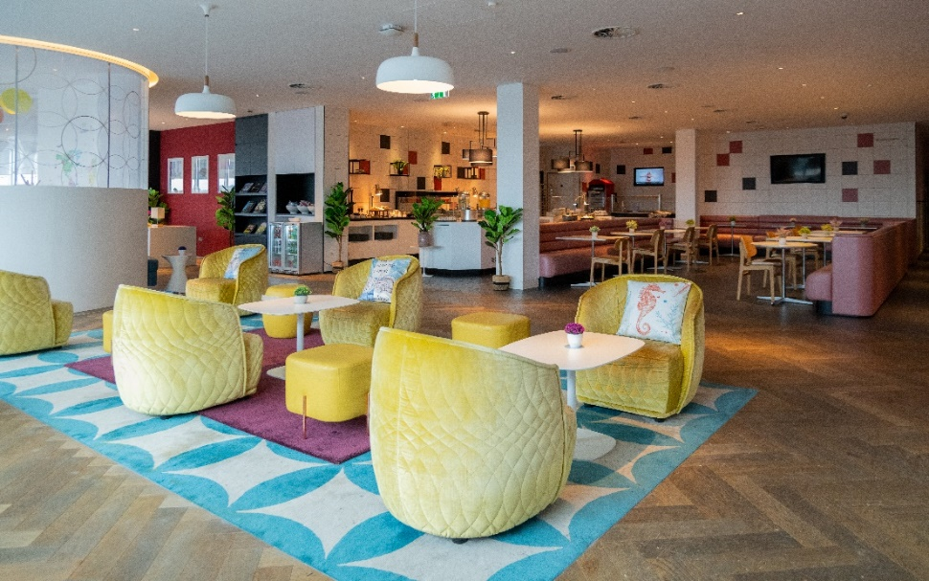

The Plaza Express offers a peaceful escape at the airport, with its airy space, abundant natural light, and tarmac views.

**London, August 2024** – Plaza Express is now open at London Gatwick Airport’s north terminal departure. The new opening is ideal for larger groups and families alike looking to kick-start their holiday in a fun and casual way, offering leisure travelers the ‘Plaza Premium Lounge’ hospitality but with more affordable entry rates, high-speed Wi-Fi, cozy zoned seating and delicious food and drink.

Tailored for travelers seeking to enjoy light bites in a cozy setting, while offering runway views and a peaceful escape from the typical departure chaos, the lounge serves a delicious choice of breakfast from the buffet in the mornings until 11am. Throughout the day, guests can visit the “build-your-own-dish” stations where guests and children alike can make their own burger, hot dog and salad at the ‘help yourself buffet’ stations, while fresh pizzas are prepared hot and fresh from the oven. All food, beer and soft drinks are unlimited.

|  |  |
| --- | --- |
|  |  |
| Travellers can enjoy light bites at our buffet station all day, including burgers, hot dogs, salads, and pizzas. | |

The family-friendly lounge – that has a dedicated play area for little ones and a pool table for the big kids – is ready to welcome guests on the first stop of their travels, open daily from 5am to 4pm. A ‘Quick and Easy’ package allows you to one-time access into Plaza Express and stay up to 1.5 hours, this includes unlimited food and beverages (£18 for adults) or you can upgrade to include wines at £25 per adult for 2 hours of access. Children under 11 go free with each accompanying adult. This can be booked in advance through the Plaza Premium Lounge website [here](https://www.plazapremiumlounge.com/en-uk/find/europe/united-kingdom/london/london-gatwick-airport/plaza-express).

This is the latest addition by the Plaza Premium Group, who owns and operates the world’s largest independent lounge network - Plaza Premium Lounge. Plaza Express marks the brand’s seventh opening in the UK and its’ second at London Gatwick, already home to the Plaza Premium Lounge also at North Terminal departure.

***Lorenzo Valori, Vice President of Commercial and Operations Europe*** said: "It's with great pleasure that we announce our UK expansion with the launch of the new Plaza Express at London Gatwick Airport. The concept created allows us to expand our offering to a wider group of travelers with affordable entry prices to a vibrant inviting space and embrace the holiday spirit.  Plaza Express is also a wonderful opportunity for large families travelling together to start their holiday in a warm, welcoming and spacious environment with an attractive entry price for adults and children. We look forward to putting smiles on our customer’s faces and continuing to bring our award-winning experience to serve travelers."

|  |  |
| --- | --- |
|  |  |
| The lounge features a play zone for children and a pool table for adults, adding an extra touch of fun to your airport experience, regardless of age. | |

**ENDS**

For further information contact:  
  
Whitney Fung, PR & Corporate Communications - Global

[whitney.fung@plaza-network.com](mailto:whitney.fung@plaza-network.com)  
  
Louise Burrows, Marketing Manager – Europe  
[louise.burrows@plaza-network.com](mailto:louise.burrows@plaza-network.com)

**Address:**

4th Floor, North Terminal Departures (near gates 45-55 and 101-103), London Gatwick Airport  
T: 01239 568 002

**Download high-res photos** [**here**](https://drive.google.com/drive/folders/1JODbcw0TZADDkbiVI-o0jVDmWs918Vto)**.**

**About Plaza Premium Group**  
Plaza Premium Group, headquartered in Hong Kong and established in 1998, is a pioneering global airport hospitality services provider. With a mission to Make Travel Better, the group introduced the world's first independent airport lounge concept.   
Today, PPG operates the largest network of international airport lounges worldwide and offers a 360-degree airport experience with 13 brands under its portfolio, spanning over 1600 touchpoints across more than 80 international airports and 30 countries & regions worldwide.

From airport lounge brands - Plaza Premium Lounge & Plaza Premium First, to terminal hotels - Aerotel & Refreshhh by Aerotel, to concierge services - ALLWAYS, a range of airport dining concepts, global reward and membership program - Smart Traveller, and travel experience ECOsystem - oneTECO, the group is at the forefront of transforming airport experience for the better through innovative and human-led solutions. PPG’s commitment extends beyond its own brands, as it also provides lounge management and hospitality solutions to leading airlines, alliances, and corporates worldwide. Partnerships include renowned names such as American Express, Capital One, Cathay Pacific Airways, SkyTeam, Star Alliance, Visa, and many more.

Plaza Premium Group has over 80 accolades demonstrating its exceptional achievements and commitment to service excellence. Notably, the group has received the prestigious "World's Best Independent Airport Lounge" award at the World Airline Awards by Skytrax for eight consecutive years from 2016 to 2024. TTG Asia also recognized the group as the "Best Airport Lounge Operator" in 2018, 2019 and 2023. In 2020, it achieved the "ISO 9001:2015" certification for its Hong Kong Headquarters. Furthermore, the group's Founder and CEO, Mr. Song Hoi-see, was awarded the “Ernst & Young Entrepreneur of the Year” and “Master Entrepreneur of the Year Malaysia” in 2018.

With a team of over 5,000 dedicated talents, PPG serves more than 20 million global passengers annually. Through a continuous pursuit of innovation and excellence, the group is experiencing exponential growth globally.

To learn more: [https://www.plazapremiumgroup.com/](https://apc01.safelinks.protection.outlook.com/?url=https%3A%2F%2Fwww.plazapremiumgroup.com%2F&data=05%7C02%7Cwhitney.fung%40plaza-network.com%7C823ef701a78940596ba708dc8c1f0f36%7C57c780997a6f42de9103b6ff47502aac%7C0%7C0%7C638539312283298306%7CUnknown%7CTWFpbGZsb3d8eyJWIjoiMC4wLjAwMDAiLCJQIjoiV2luMzIiLCJBTiI6Ik1haWwiLCJXVCI6Mn0%3D%7C0%7C%7C%7C&sdata=WJt3N4EG0YzmKgURoRWdOKWSeTVXas86Nat6b9Pb8cE%3D&reserved=0)

Connect with us: FB, IG, @plazapremiumlounge and WeChat @PlazaPremiumGroup