**Plaza Premium Group and Adelaide Airport Partner to Launch Flight Club Adelaide**

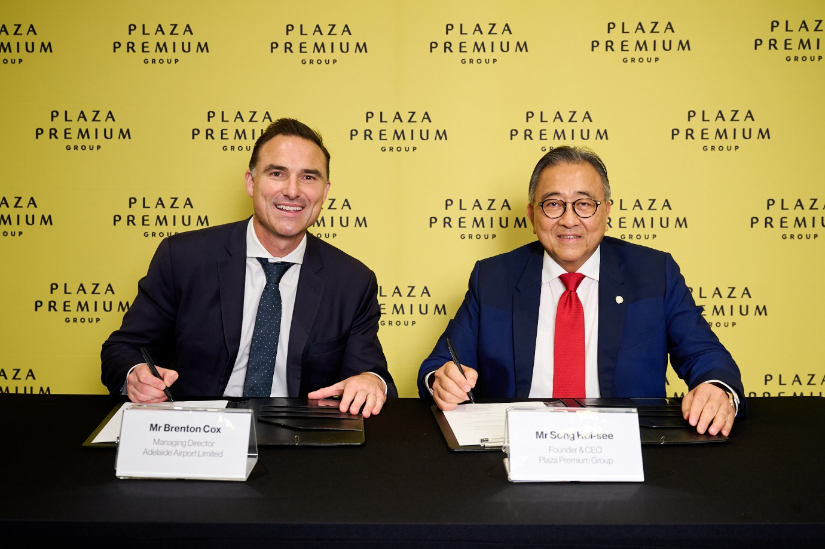

***Adelaide, Australia – [25, November 2024]*** – Plaza Premium Group (PPG) and Adelaide Airport are excited to announce they have signed an agreement to introduce Flight Club Adelaide, PPG’s first domestic terminal experience in Oceania and the debut of the Flight Club brand in the region. Located within the Domestic departure hall at Adelaide Airport, Flight Club Adelaide will offer a tranquil, welcoming space for travellers to relax, dine, and recharge, building on the success of the existing Plaza Premium Lounge in the International Terminal.

The new Flight Club Adelaide aims to elevate the pre-flight experience while celebrating the rich flavours and unique character of South Australia. Aligned with PPG’s Proudly Local initiative, the Flight Club experience will feature a variety of offerings crafted from locally sourced ingredients, providing a taste of the region for guests in an aviation inspired setting with a sleek contemporary design.

Designed to cater to all travellers, Flight Club Adelaide will especially appeal to today’s digital-savvy generation, offering an accessible, premium experience at an affordable price. With its blend of comfort, convenience, and quality dining, Flight Club Adelaide invites guests of all ages to enjoy a premium environment without breaking the budget.

Mr. Song Hoi See, Founder and CEO of PPG, stated: “Australia has always been an important market for PPG, and we have been growing since we opened Australia's first independent international airport lounge in Brisbane in 2016. Last year, we expanded in South Australia, opening the 'First and only' international lounge at Adelaide Airport, another key hub of the country. Given that a substantial proportion of flights flying through Adelaide are domestic and this market is still growing, we believe there is a rising demand for airport hospitality experiences."

Brenton Cox, Managing Director, Adelaide Airport, said, “We’re delighted to welcome Flight Club Adelaide, which can be accessed by all of our customers regardless of which airline they are flying with. This new experience will align with our retail vision to ‘unwrap the best of South Australia’ by featuring South Australian brands and locally sourced ingredients, and complements the highly successful Plaza Premium lounge in our international departures precinct.”

Poh Kiat Lee, Regional General Manager, Oceania added: "We are honoured to collaborate with Adelaide Airport once again, this project marks another significant step in our expansion both domestically and globally. Our vision with Flight Club Adelaide is to create an innovative experience that captures the essence of South Australia and brings value to a diverse range of travellers.

Flight Club Adelaide is set to open in mid-2025, with further updates to be shared closer to the launch date.

- end -

**About Plaza Premium Group**

Plaza Premium Group, headquartered in Hong Kong and established in 1998, is a pioneering global airport hospitality services provider. With a mission to Make Travel Better, the group introduced the world's first independent airport lounge concept.

Today, PPG operates the largest network of international airport lounges worldwide and offers a 360-degree airport experience with 14 brands under its portfolio, spanning over 1,600 touchpoints in 150 countries across 600 international and domestic airports. From airport lounge brands - Plaza Premium Lounge & Plaza Premium First, to terminal hotels - Aerotel & Refreshhh by Aerotel, to concierge services - ALLWAYS, a range of airport dining concepts, global reward and membership program - Smart Traveller, and travel experience ECOsystem - oneTECO, the group is at the forefront of transforming airport experience for the better through innovative and human-led solutions. PPG’s commitment extends beyond its brands, as it also provides lounge management and hospitality solutions to leading airlines, alliances, and corporates worldwide. Partnerships include renowned names such as American Express, Capital One, Cathay Pacific Airways, SkyTeam, Star Alliance, Visa, and many more.

Plaza Premium Group has over 100 accolades demonstrating its exceptional achievements and commitment to service excellence. Notably, the group has received the prestigious "World's Best Independent Airport Lounge" award at the World Airline Awards by Skytrax for eight consecutive years from 2016 to 2024. TTG Asia also recognized the group as the "Best Airport Lounge Operator" in 2018, 2019 and 2023. In 2020, it achieved the "ISO 9001:2015" certification for its Hong Kong Headquarters. Furthermore, the group's Founder and CEO, Mr. Song Hoi-see, was awarded the “Ernst & Young Entrepreneur of the Year” and “Master Entrepreneur of the Year Malaysia” in 2018.

With a team of over 5,000 dedicated talents, PPG serves more than 20 million global passengers annually. Through a continuous pursuit of innovation and excellence, the group is experiencing exponential growth globally.

 To learn more: [https://www.plazapremiumgroup.com/](https://apc01.safelinks.protection.outlook.com/?url=https%3A%2F%2Fwww.plazapremiumgroup.com%2F&data=05%7C02%7Cwhitney.fung%40plaza-network.com%7Cf572f40458854f1c2dcf08dd0ceb0fc2%7C57c780997a6f42de9103b6ff47502aac%7C0%7C0%7C638680925906233576%7CUnknown%7CTWFpbGZsb3d8eyJFbXB0eU1hcGkiOnRydWUsIlYiOiIwLjAuMDAwMCIsIlAiOiJXaW4zMiIsIkFOIjoiTWFpbCIsIldUIjoyfQ%3D%3D%7C0%7C%7C%7C&sdata=I4X%2BQjsnVCKSJS1CYxaGKqzdiRnDUnvBYYnbMVA14W8%3D&reserved=0)

Connect with us: FB, IG, @plazapremiumlounge and WeChat @PlazaPremiumGroup

For any further information, please contact:

Josh Williams

Marketing Officer, Plaza Premium Group Oceania

E: [josh.williams@plaza-network.com](mailto:josh.williams@plaza-network.com)

Whitney Fung

PR & Corporate Communications, Plaza Premium Group

E: whitney.fung@plaza-network.com