**PLAZA PREMIUM GROUP BECOMES WORLD’S FIRST INTERNATIONAL AIR TRANSPORT ASSOCIATION (IATA) STRATEGIC PARTNER IN ACCESSIBILITY**

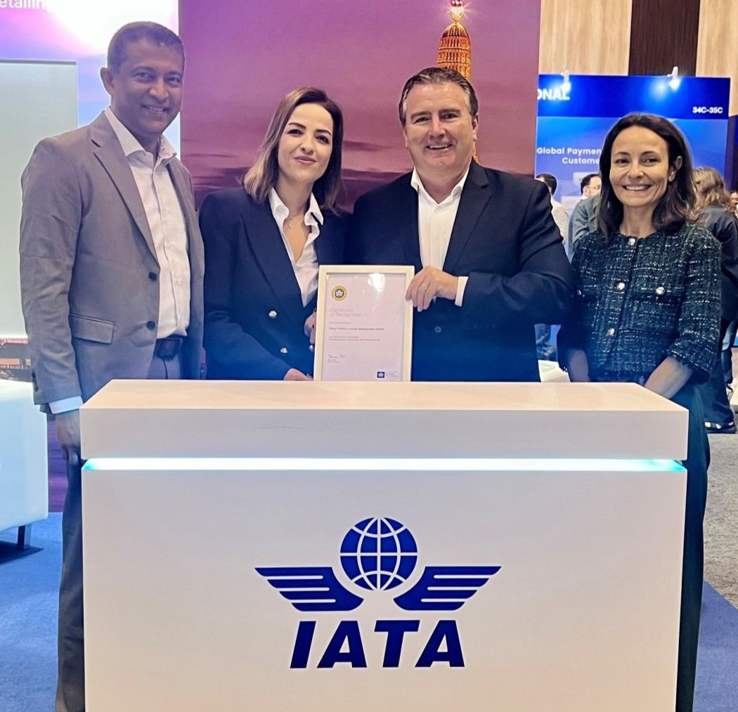

Left to right: Chamil Liyanage, Managing Director, Airport Passenger and Hospitality Services, Plaza Premium Group; Mira Al-Hmoud, Associate Director, Strategy and Commercial Development, Plaza Premium Group; Nick Careen, Senior Vice President Operations, Safety and Security, International Air Transport Association ; Linda Ristagno, Assistant Director, External Affairs/Policy, International Air Transport Association

[19th December 2024 - Hong Kong] Airlines worldwide aim to ensure safe, reliable, and dignified travel for every traveller, especially passengers with disabilities. The commitment of Plaza Premium Group (PPG) to inclusive travel has culminated in a major milestone in which PPG was recently recognised as the world’s first International Air Transport Association (IATA) Strategic Partner in Accessibility. Plaza Premium Group actively supports inclusive travel wherein mindful and thoughtful services are offered to all.

“Everyone deserves a pleasurable and convenient travel experience. Everyone deserves to see the world and we believe in making travel better for all. This pioneering recognition extends beyond the validation of our commitment, it represents a transformative step in our mission to ensure exceptional travel experiences are universally accessible to all passengers, with full inclusion. Through this strategic partnership, we're proudly setting new standards for inclusive travel and airport hospitality,” stated Bora Isbulan, Deputy Chief Executive Officer. “It demonstrates our innovative capabilities and technology in delivering end-to-end passenger solutions.” This also strengthens the company’s ESG credentials, particularly in social inclusion and accessibility leadership.

Plaza Premium Group (PPG) is the company that started offering inclusive airport hospitality services through its brand ALLWAYS which was first introduced in 2012. ALLWAYS provides a comprehensive range of passenger services designed to enhance the travel experience. These services include meet and assist, porter service, wheelchair assistance, and concierge services, among others, catering to diverse traveller needs. ALLWAYS is committed to making its services accessible to all travellers, not just those flying in premium classes. This inclusive approach reflects PPG's mission to enhance travel for everyone, addressing diverse needs and preferences.

To further optimize its operations and enhance the seamlessness, ALLWAYS utilizes oneTECO (One Travel Experience Ecosystem), an omnichannel booking engine developed by PPG, which is a key project under the group's US$10 million technology investment.

This platform centralizes all the airport passenger services and allows travellers to conveniently book services online before arriving at the airport. This integration simplifies the booking process for both consumers and business operators, ensuring a more user-friendly experience. Overall, ALLWAYS sets itself apart by combining a wide array of services into a cohesive offering that prioritizes convenience, personalization, and accessibility for all travellers.

The ALLWAYS platform aims to create seamless travel experiences by integrating various services into a single offering, making it convenient for passengers from arrival to departure. This initiative reflects PPG's commitment to elevating airport hospitality and meeting the growing demand for inclusive services in the aviation sector.

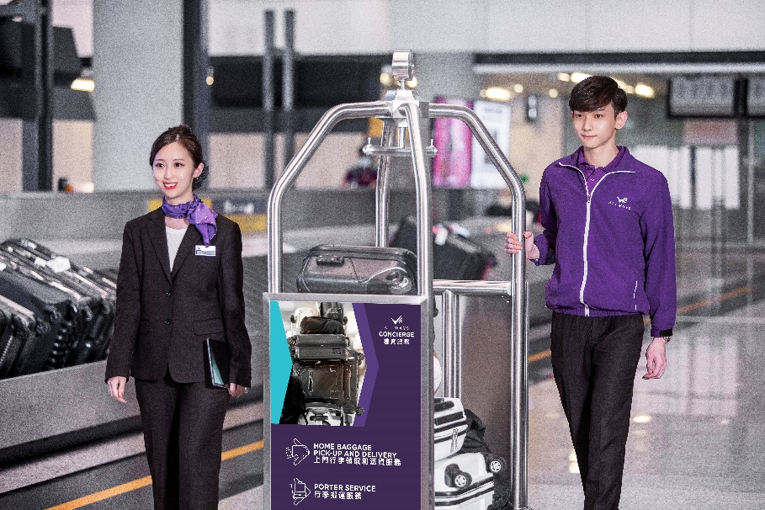

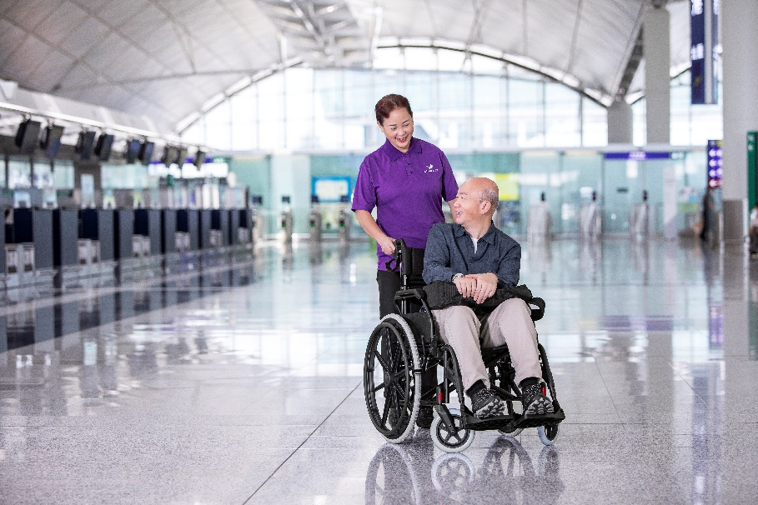

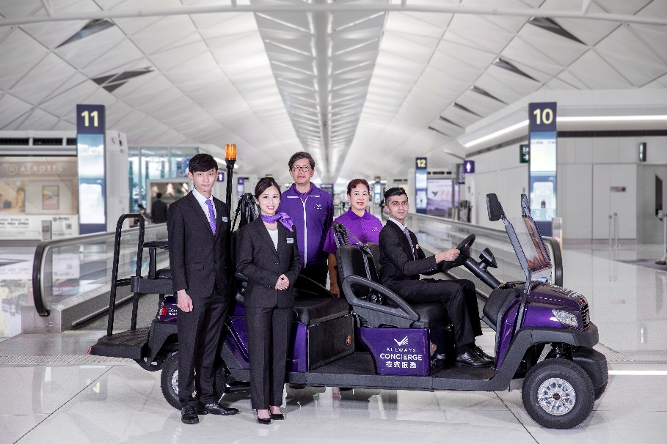

**Download photos here:** [**https://www.dropbox.com/scl/fo/6m7lcw6rifcl9hksqravf/AICWwPXL16DqjwzAO3bXfT0?rlkey=5odpac8m1cpur78i6h1ewb6s3&st=bgpven5s&dl=0**](https://www.dropbox.com/scl/fo/6m7lcw6rifcl9hksqravf/AICWwPXL16DqjwzAO3bXfT0?rlkey=5odpac8m1cpur78i6h1ewb6s3&st=bgpven5s&dl=0)

**About Plaza Premium Group**

Plaza Premium Group, headquartered in Hong Kong and established in 1998, is a pioneering global airport hospitality services provider. With a mission to Make Travel Better, the group introduced the world's first independent airport lounge concept. 

Today, PPG operates the largest network of international airport lounges worldwide and offers a 360-degree airport experience with 14 brands under its portfolio, spanning over 1600 touchpoints across more than **75** international airports and 30 countries & regions worldwide.

From airport lounge brands - Plaza Premium Lounge & Plaza Premium First, to terminal hotels - Aerotel & Refreshhh by Aerotel, to concierge services - ALLWAYS, a range of airport dining concepts, global reward and membership program - Smart Traveller, and travel experience ECOsystem - oneTECO, the group is at the forefront of transforming airport experience for the better through innovative and human-led solutions. PPG’s commitment extends beyond its own brands, as it also provides lounge management and hospitality solutions to leading airlines, alliances, and corporates worldwide. Partnerships include renowned names such as American Express, Capital One, Cathay Pacific Airways, SkyTeam, Star Alliance, Visa, and many more.

Plaza Premium Group has over **100 accolades** demonstrating its exceptional achievements and commitment to service excellence. Notably, the group has received the prestigious "World's Best Independent Airport Lounge" award at the World Airline Awards by Skytrax for eight consecutive years from 2016 to 2024. TTG Asia also recognized the group as the "Best Airport Lounge Operator" in 2018, 2019 and 2023. In 2020, it achieved the "ISO 9001:2015" certification for its Hong Kong Headquarters. Furthermore, the group's Founder and CEO, Mr. Song Hoi-see, was awarded the “Ernst & Young Entrepreneur of the Year” and “Master Entrepreneur of the Year Malaysia” in 2018.

With a team of over 5,000 dedicated talents, PPG serves more than 20 million global passengers annually. Through a continuous pursuit of innovation and excellence, the group is experiencing exponential growth globally.

 To learn more: [https://www.plazapremiumgroup.com/](https://apc01.safelinks.protection.outlook.com/?url=https%3A%2F%2Fwww.plazapremiumgroup.com%2F&data=05%7C02%7Cwhitney.fung%40plaza-network.com%7Cb73228f69649471153ed08dc8c4b2e82%7C57c780997a6f42de9103b6ff47502aac%7C0%7C0%7C638539501783740352%7CUnknown%7CTWFpbGZsb3d8eyJWIjoiMC4wLjAwMDAiLCJQIjoiV2luMzIiLCJBTiI6Ik1haWwiLCJXVCI6Mn0%3D%7C0%7C%7C%7C&sdata=e1yaoen78nb4kWIILR4XwqpHpbtRvi5CKGWQ1hcLd0A%3D&reserved=0)

Connect with us: FB, IG, @plazapremiumlounge and WeChat @PlazaPremiumGroup

Media contact:  
Whitney Fung   
Plaza Premium Group PR & Corporate Communications   
[whitney.fung@plaza-network.com](mailto:whitney.fung@plaza-network.com)