FOR IMMEDIATE RELEASE
Plaza Premium Group Champions Hospitality Innovation at JUMPSTARTER 2025,
Asia’s Leading Startup Event

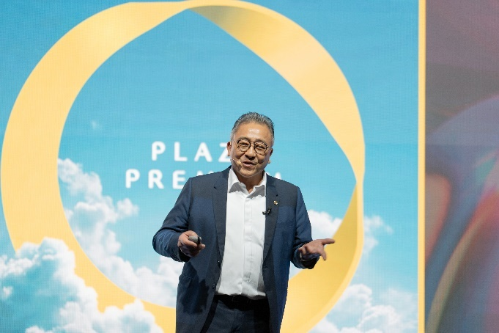 | 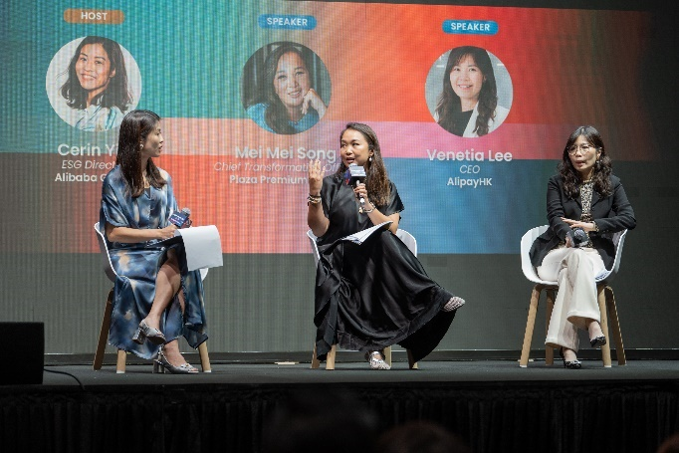
Mr. Song Hoi See, Founder and CEO of Plaza Premium Group, delivered the keynote speech on "Leading with Vision: Pioneering Innovation and Transforming Global Travel” | Ms. Mei Mei Song, Chief Transformation Officer of Plaza Premium Group, participated in the panel discussion "How AI is Reshaping the Future of Lifestyle”

Hong Kong, 10 April 2025 – Plaza Premium Group (PPG), the global leader in integrated airport hospitality services, proudly partnered as the Hospitality Partner for JUMPSTARTER 2025, Asia's premier startup and tech event organized by the Alibaba Entrepreneurs Fund. Held on 26-27 March 2025 at AsiaWorld-Expo, the event brought together innovative startups, investors, corporates, and industry experts to foster entrepreneurship and innovation.
PPG's participation was marked by several key highlights. As the Hospitality Partner, PPG exclusively sponsored the VIP Lounge, offering a bespoke experience for high-profile attendees, including speakers, corporate leaders, and investors. The lounge provided a comfortable setting with curated food and beverage services, creating a welcoming atmosphere for networking and relaxation.
The event also featured inspiring contributions from PPG leadership. Mr. Song Hoi See, Founder and CEO of Plaza Premium Group, delivered a keynote speech titled "Leading with Vision: Pioneering Innovation and Transforming Global Travel", sharing his journey of building a global airport hospitality company. Ms. Mei Mei Song, Chief Transformation Officer of PPG, participated in a panel discussion on "How AI is Reshaping the Future of Lifestyle," reinforcing PPG's active engagement in innovation.

The "Celebration Drinks" event on the final evening was another standout moment, where PPG hosted a joyful experience for over 200 guests. The event featured Intervals Bar's signature cocktails and canapés. Imelda Ng, the Beverage Manager at Intervals, presented her award-winning cocktail, “Holiday Mood”, marking a memorable conclusion to the JUMPSTARTER Grand Finale. Furthermore, PPG offered 3-hour complimentary lounge access to Plaza Premium First, a luxurious haven known for its personalized service and exquisite dining, to the top 5 teams from the One Earth Global Pitch Competition.
Through its involvement in JUMPSTARTER 2025, Plaza Premium Group reaffirmed its role as a champion of innovation and hospitality excellence in support of global entrepreneurship.
Please click here for the video highlights of the event.
Download high-resolution photos here.

About Plaza Premium Group
Plaza Premium Group (PPG) is the global leader in integrated airport hospitality and passenger service solutions, operating the largest network of airport lounges worldwide and offering a 360-degree airport hospitality experience with 14 brands under its portfolio, operating in 150 countries across 600 international and domestic airports and serving 24 million passengers annually. With a mission to Make Travel Better, the group introduced the world's first independent airport lounge concept in 1998.
Plaza Premium Lounge, Plaza Premium First - award-winning airport lounges, Aerotel - the world’s largest airport transit hotel chain, Refreshhh by Aerotel, ALLWAYS - airport passenger services, airport dining concepts, Smart Traveller - innovative digital experience and rewards platform, and One Travel Experience Ecosystem (oneTECO), the group is at the forefront of transforming airport experiences for the better through innovative and human-led solutions. PPG’s commitment extends beyond its brands, as it also provides lounge management and hospitality solutions to leading airlines, alliances, and corporates worldwide. Partnerships include renowned names such as American Express, Capital One, Cathay Pacific Airways, SkyTeam, Star Alliance, Visa, and many more.
Plaza Premium Group has over 100 accolades, demonstrating its exceptional achievements and commitment to service excellence. Notably, the group has received the prestigious "World's Best Independent Airport Lounge" award at the World Airline Awards by Skytrax for eight consecutive years from 2016 to 2024.
With a team of over 6,000 dedicated talents worldwide, and through a continuous pursuit of innovation and excellence, the group is experiencing exponential growth globally.
To learn more: https://www.plazapremiumgroup.com
Connect with us: LinkedIn, Facebook, IG @PlazaPremiumLounge, IG @mysmarttraveller, X, and YouTube

Media Contact
Plaza Premium Group
PR & Corporate Communications - Global
Virginia Luk
Email: virginia.luk@plaza-network.com

