FOR IMMEDIATE RELEASE

Plaza Premium Lounge Opens at Senai International Airport
– A New Standard in Airport Hospitality for Johor Bahru

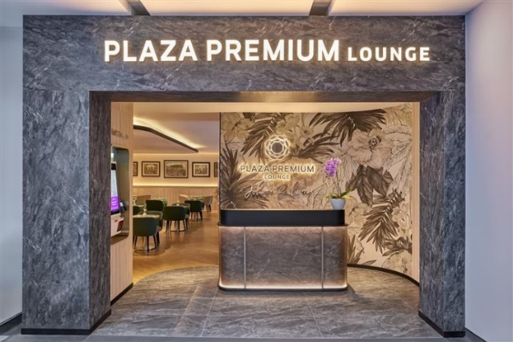 | 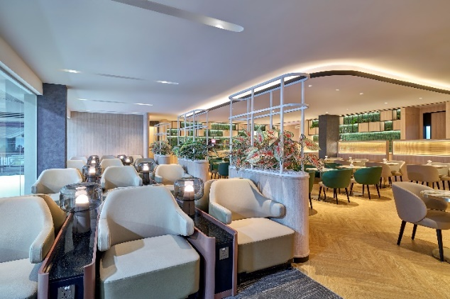

[Hong Kong, 19 June 2025] – Plaza Premium Group is proud to announce the soft opening of Plaza Premium Lounge Johor Bahru at Senai International Airport (JHB). As the only lounge operator in the airport, the 80-seater lounge promises to deliver an elevated, seamless and culturally rich experience to both international and domestic travellers under one roof.

Designed to blend cutting-edge technology with local Malaysian heritage, Plaza Premium Lounge Johor Bahru offers a premium, comfortable and innovative space for guests, providing an ideal environment before their flight, whether travelling near or far.

As the exclusive lounge operator at Senai International Airport, Plaza Premium Lounge Johor Bahru is a game-changer for the region. Unlike many other airport lounges, the space caters to both international and domestic travellers, offering the same level of premium service, whether they are flying across the globe or within Malaysia.

The lounge is well equipped with state-of-the-art technology to streamline the guest experience such as self check-in kiosks for a more efficient and hassle-free access to the lounge. Implementation of QR code-based food ordering system also allows lounge guests to browse and order their meals effortlessly. With the aim to further enhance lounge experience with digital solutions, this lounge has actively integrated the Smart Traveller app which enable personalised experiences, rewards and a smooth transition through the lounge and airport.

For passengers on tight schedules, Plaza Premium Lounge Johor Bahru introduces the Lounge To-Go corner for ultimate convenience. This dedicated space offers travellers the option to grab a premium selection of food and beverages to enjoy on the go, without compromising on quality.

As part of the Proudly Local concept, the lounge goes beyond comfort and convenience to offer a true cultural immersion, celebrating the vibrant heritage of Malaysia in every dimension. Authentic local food and beverage choices give guests the opportunity to experience a true taste of Johor Bahru and Malaysia, with regional flavours and delicacies that showcase the richness of the country’s culinary heritage. Signature dishes such as Otak-Otak (spiced fish paste wrapped in banana leaves and grilled to perfection) and Laksa Johor which truly sets itself apart from other types of laksa. While most versions across Malaysia are served as soup, this unique dish from Johor resembles a plate of spaghetti bolognese. It features yellow noodles generously coated in a rich, flavourful gravy. The sauce is made with coconut milk, asam gelugur, dried prawns, lemongrass, galangal, and a blend of aromatic spices, creating a hearty and memorable meal.

Discover local artworks by Malaysian artists which are prominently featured throughout the lounge, offering a unique and immersive experience for guests. With the opportunity to purchase the art pieces, this turns the lounge into a cultural hub where guests can support and engage with local creativity.

“Plaza Premium Lounge Johor Bahru is more than just a place to wait for your flight – it’s a space to experience the best of Johorian hospitality, art and innovation,” said Cavin Loh, Regional General Manager (Southeast Asia) from Plaza Premium Group. “Returning to Johor Bahru with Plaza Premium Lounge is an exciting moment for us. By seamlessly blending technology with local culture, we are excited to redefine the travel experience for both domestic and international passengers at Senai International Airport.”

Visit www.plazapremiumlounge.com to make reservations.

For high resolution images, kindly download from here:
https://mega.nz/folder/Oj4kCCxA#1WjpHoxMDQiheI4mHvbwEw

- End -

About Plaza Premium Group

Plaza Premium Group (PPG) is the global leader in integrated airport hospitality and passenger service solutions, operating the largest network of airport lounges worldwide and offering a 360-degree airport hospitality experience with 14 brands under its portfolio, operating in 150 countries across 600 international and domestic airports and serving 24 million passengers annually. With a mission to Make Travel Better, the group introduced the world's first independent airport lounge concept in 1998. Plaza Premium Lounge, Plaza Premium First - award-winning airport lounges, Aerotel - the world’s largest airport transit hotel chain, Refreshhh by Aerotel, ALLWAYS - airport passenger services, airport dining concepts, Smart Traveller - innovative digital experience and rewards platform, and One Travel Experience Ecosystem (oneTECO), the group is at the forefront of transforming airport experiences for the better through innovative and human-led solutions. PPG’s commitment extends beyond its brands, as it also provides lounge management and hospitality solutions to leading airlines, alliances, and corporations worldwide. Partnerships include renowned names such as American Express, Capital One, Cathay Pacific Airways, Saudia, SkyTeam, Star Alliance, Visa, and many more. Plaza Premium Group has over 100 accolades, demonstrating its exceptional achievements and commitment to service excellence. Notably, the group has received the prestigious "World's Best Independent Airport Lounge" award at the World Airline Awards by Skytrax for nine consecutive years from 2016 to 2025. With a team of over 6,000 dedicated professionals worldwide, and through a continuous pursuit of innovation and excellence, the group is experiencing exponential growth globally.

To learn more: https://www.plazapremiumgroup.com

Connect with us: LinkedIn, YouTube: @Plaza Premium Group; Facebook, Instagram: @plazapremiumlounge; X: @We_Are_PPG; WeChat, Weibo, Xiaohongshu: @環亞全球出行PlazaPremiumGroup; Instagram (mysmarttraveller): @mysmarttraveller

Media Contact:
Virginia Luk
Plaza Premium Group
PR & Corporate Communications – Global
Email: virginia.luk@plaza-network.com

